Lab 1: Add HTML to Your Resume

In Lab 1 you will add HTML markup to your resume. The objective of this lab assignment is to learn the Work Flow described in the Module 1 slideshow. If you don't have a resume, I have a sample resume below to get you started on creating a resume.



Before starting this lab, study, do the exercises, and watch the videos in the [Introduction to Web Development](https://docs.google.com/presentation/d/1tVUDgay48uKvB3wDOuVUvmYDVDTu74omg5H3hpCkV_k/edit?usp=sharing) slideshow.

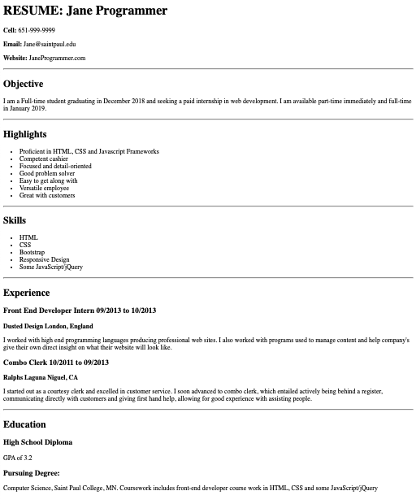

**Step 1.** Open the text editor you installed in the Module 1 slideshow.

**Step 2.** Create a new document called resume.html. (In Sublime Text, use File->New, then File->Save As.) On Windows, save the file type as "html". (On a Mac, you can just name the file with ".html".)

**Step 3.** Cut and paste the content of your resume into the text editor. If you don't have a resume, you can use the sample resume below to get you started on your resume.

**Step 4.** View it on Chrome. As demonstrated in the slideshow and video, set up your workplace with your Text Editor on one half of your screen and the Chrome Developer Tools on the other half.

**Step 5.** Add HTML markup to your resume. In the slideshow we covered the following HTML elements:

* <p>Text here for paragraphs</p>
* <h1>Title here for a title</h1> You can also use <h2>, <h3>....<h6> for subtitles. For a resume, you would generally make each major category into an <h2>
* <b>Bold text</b>
* <hr> for a horizontal rule

Every phrase on your resume should have some markup.

**Step 6. Optional Challenge**: Add a bulleted list to your resume. Here is how you code a bulleted list. (We will learn how to make a bulleted list next week in Module 2/Chapter 2.)

<ul>

<li>Gryffindor</li>

<li>Hufflepuff</li>

<li>Slytherin</li>

<li>Ravenclaw</li>

</ul>

Once you have finished work on your resume, upload your file to the D2L Assignment Folder for Lab 1. If you are in an in-person or Zoom class, I will grade your lab assignment in class.

*Note: If you have worked in HTML before, you probably noticed that we skipped a lot of required HTML on a web page. Don't worry. We'll get to that next week*. *The goal of this week is just to get students used to the HTML syntax.*

************************************************************************************************

# **Sample Resume**

Use this as a starting point for the lab if you don't have a resume. Change the content to your content. For example, change "Jane Programmer" to your name. Everything in your resume must be true for YOU.

RESUME

Jane Programmer

Cell: 651-999-9999

Email: [Jane@saintpaul.edu](mailto:Jane@saintpaul.edu)

Website: JaneProgrammer.com

**Objective**

I am a Full-time student graduating in December 2018 and seeking a paid internship in web development. I am available part-time immediately and full-time in January 2019.

**Highlights**

Proficient in HTML, CSS and Javascript Frameworks

Competent cashier

Focused and detail-oriented

Good problem solver

Easy to get along with

Versatile employee

Great with customers

**Skills**

HTML, CSS, Bootstrap, Responsive Design and some JavaScript/jQuery

**Experience**

Front End Developer Intern 09/2013 to 10/2013

*Dusted Design London, England*

I worked with high end programming languages producing professional web sites. I also worked with programs used to manage content and help company's give their own direct insight on what their website will look like.

Combo Clerk 10/2011 to 09/2013

*Ralphs Laguna Niguel, CA*

I started out as a courtesy clerk and excelled in customer service. I soon advanced to combo clerk, which entailed actively being behind a register, communicating directly with customers and giving first hand help, allowing for good experience with assisting people.

**Education**

High School Diploma

Pursuing Degree: Computer Science, Saint Paul College, MN. Coursework includes front-end developer course work in HTML, CSS and some JavaScript/jQuery

*********************************************************************************************

# Coding Solution

Feeling Stuck? This is how I coded the resume in the screenshot above. Try to do the lab assignment on your own. There is more than one right way to code the resume.

